**Web Technology for bioinformatics**

Name - Dharineesh K S Date - 06/11/2021

Regno - 123013012 Ex.no - 06

**Aim :**

To calculate the Dihedral angles for the given protein and to develop RAMACHANDRAN plot using the GD module in PHP.

**Algorithm Steps:**

**PHI angle calculation:**

i)Extract the x,y,z coordinates of N,CA,C of the current residue and carbon atom of

previous residue .

Example

d1 stores the x,y,z coordinates of carbon atom of previous residue

d2 stores the x,y,z coordinates of Nitrogen atom of current residue

d3 stores the x,y,z coordinates of Alpha Carbon atom of current residue

d4 stores the x,y,z coordinates of Carbon atom of current residue

ii)Find the vectors for the atoms using the extracted x,y,z coordinates.

Example :

v1= find the distance between “N” and “C”

v2= find the distance between “N” and “CA”

v3= find the distance between “C” and “CA”

(v1 is an array which stores 3 values as follows

v1[0] =&gt; x coordinate of N-C

v1[1] =&gt; y coordinate of N-C

v1[2] =&gt; z coordinate of N-C ).

iii)Find the cross product for the v1 and v2 vectors and get the value in a variable

(assume it is “p1” ).

iv)Find the cross product for the v2 and v3 vectors and get the value in a variable

(assume it is “q”).

Finding Cross product between the two vectors:(v1 ,v2)

p1[0]=v1[1]*v2[2]-v1[2]*v2[1];

p1[1]=v1[2]*v2[0]-v1[0]*v2[2];

p1[2]=v1[0]*v2[1]-v1[1]*v2[0];

These values correspond to the array “p1”.

**Find the angle between “p” and “q”:**

Before finding the angle , find the dot product of “p” and “q” and find the length of a

vector.

W.k.t ,

p1 . p2 = |p1| |p2| cos (phi)

Then cos (phi)= p1 . p2/|p1| |p2|

sinsq=1-cos 2 (phi)

sin(phi)=sqrt(sinsq);

phi=atan2[sin(phi)/cos(phi)

**PSI calculation:**

i)Extract the x,y,z coordinates of N,CA,C of the current residue and nitrogen atom of

next residue .

Example

d1 stores the x,y,z coordinates of Nitrogen atom of current residue

d2 stores the x,y,z coordinates of Alpha carbon of current residue

d3 stores the x,y,z coordinates of carbon atom of current residue

d4 stores the x,y,z coordinates of Nitrogen atom of next residue

ii)Find the vectors for the atoms using the extracted x,y,z coordinates.

v1= find the distance between “CA” and “N

v2= find the distance between “CA” and “C”

v3= find the distance between “N” and “C”

(v1 is an array which stores 3 values as follows

v1[0] =&gt; x coordinate of CA-N

v1[1] =&gt; y coordinate of CA-N

v1[2] =&gt; z coordinate of CA-N )

Follow the similar steps for remaining calculations .

**Program:**

**The code below is written in an html file:**

**<!DOCTYPE html>**

**<head>**

**<title>Uploading pdb file</title>**

**</head>**

**<body>**

**<!-- name : Dharineesh K S**

**regno : 123013012 -->**

**<form method="post" action="dihedral.php" enctype="multipart/form-data">**

**<center>**

**<label>Upload PDB file</label>**

**<input type="file" name="pdb">**

**<br>**

**<br>**

**<input type="submit" value="upload file">**

**</center>**

**</form>**

**</body>**

**</html>**

**Output of html script:**



**Program:**

**The code below is written in a php file:**

**<?php**

**# name : Dharineesh K S**

**# regno : 123013012**

**$filename = $_FILES['pdb']['name'];**

**$location = $_FILES['pdb']['tmp_name'];**

**move_uploaded_file($location,$filename);**

**$handle = fopen($filename,"r");**

**$pdb_resnumber = array();**

**$atom_coordinate = array();**

**$j = 0;**

**$noofatom = 0;**

**while(!feof($handle))**

**{**

**$line = fgets($handle);**

**if(preg_match("/^ATOM/",$line))**

**{**

**#echo "$line <br>";**

**#ATOM 1 N THR A 1 17.047 14.099 3.625 1.00 13.79 N**

**if(preg_match("/\d{1,5}\s{2,3}[NC]\s{1,}/",$line) || preg_match("/\d{1,5}\s{2,3}CA\s{1,}/",$line))**

**{**

**#echo "$line <br>";**

**$resno = substr($line,23,3);**

**$pdb_resnumber[$j] = $resno;**

**$atom_coordinate[$j] = $line;**

**$j++;**

**$noofatom++;**

**}**

**}**

**}**

**//print_r($pdb_resnumber);**

**//print_r($atom_coordinate);**

**$uniq = array_unique($pdb_resnumber);**

**//print_r($uniq);**

**#echo "<br>";**

**$aapdb = array();**

**$k = 0;**

**foreach($uniq as $key)**

**{**

**$aapdb[$k] = (int)$key;**

**$k++;**

**}**

**//print_r($aapdb);**

**$u = 3; // to extract the previous residue for phi**

**$psi_count = 3; // to move to next set of co-ordinates for psi**

**#phi calc**

**for($i=1;$i<count($aapdb)-1;$i++) #i =1, getting residue number = 2**

**{**

**$current_coordinate = array();**

**for($j=0;$j<count($atom_coordinate);$j++) # get the residue number**

**{**

**$residue_number_from_coordinate = (int)trim(substr($atom_coordinate[$j],23,3));**

**if($aapdb[$i] == $residue_number_from_coordinate)**

**{**

**array_push($current_coordinate,$atom_coordinate[$j]);**

**}**

**}**

**// calling func for calc**

**ab($current_coordinate);**

**}**

**// func for calc**

**function ab($cc)**

**{**

**//print_r($cc);**

**$cur = substr($cc[0],23,3);**

**phi($cur,$cc);**

**psi($cur,$cc);**

**}**

**function phi($p,$dd)**

**{**

**global $atom_coordinate, $u;**

**$cc = $atom_coordinate[$u-1]; // to extract previous residue carbon atom**

**# extracting x,y,z coordinates**

**preg_match_all("/-?\d{1,2}\.\d{3}/",$cc ,$d1); // x,y,z of previous residue carbon atoms**

**preg_match_all("/-?\d{1,2}\.\d{3}/",$dd[0],$d2); // x,y,z of current nitrogen atoms**

**preg_match_all("/-?\d{1,2}\.\d{3}/",$dd[1],$d3); // x,y,z of current CA atoms**

**preg_match_all("/-?\d{1,2}\.\d{3}/",$dd[2],$d4); // x,y,z of current carbon atoms**

**#declaring vectors**

**$v1 = array();**

**$v2 = array();**

**$v3 = array();**

**for ($m=0;$m<3;$m++)**

**{**

**$v1[$m] = $d2[0][$m] - $d1[0][$m];**

**$v2[$m] = $d2[0][$m] - $d3[0][$m];**

**$v3[$m] = $d4[0][$m] - $d3[0][$m];**

**}**

**$p = cross($v1,$v2);**

**$q = cross($v2,$v3);**

**$phi_angle = angle($p,$q);**

**print "Phi angle is $phi_angle <br>";**

**}**

**// psi angle calc**

**function psi($p,$dd)**

**{**

**global $atom_coordinate, $psi_count;**

**$pss = $atom_coordinate[$psi_count+3]; // to extract previous residue carbon atom**

**# extracting x,y,z coordinates**

**preg_match_all("/-?\d{1,2}\.\d{3}/",$dd[0],$d1); // x,y,z of current nitrogen atoms**

**preg_match_all("/-?\d{1,2}\.\d{3}/",$dd[1],$d2); // x,y,z of current CA atoms**

**preg_match_all("/-?\d{1,2}\.\d{3}/",$dd[2],$d3); // x,y,z of current carbon atoms**

**preg_match_all("/-?\d{1,2}\.\d{3}/",$pss ,$d4); // x,y,z of next residue nitrogen atoms**

**#declaring vectors**

**$v1 = array();**

**$v2 = array();**

**$v3 = array();**

**for ($m=0;$m<3;$m++)**

**{**

**$v1[$m] = $d2[0][$m] - $d1[0][$m];**

**$v2[$m] = $d2[0][$m] - $d3[0][$m];**

**$v3[$m] = $d4[0][$m] - $d3[0][$m];**

**}**

**$p = cross($v1,$v2);**

**$q = cross($v2,$v3);**

**$psi_angle = angle($p,$q);**

**print "Psi angle is $psi_angle <br>";**

**}**

**function cross($r1,$r2)**

**{**

**$p1[0] = $r1[1]*$r2[2] - $r1[2]*$r2[1];**

**$p1[1] = $r2[2]*$r2[0] - $r1[0]*$r2[2];**

**$p1[2] = $r1[0]*$r2[1] - $r1[1]*$r2[0];**

**return $p1;**

**}**

**function angle($a1,$a2)**

**{**

**$cos_theta = dot($a1,$a2)/(len($a1)*len($a2));**

**$sin_sqr_theta = 1-($cos_theta*$cos_theta);**

**if($sin_sqr_theta<0)**

**{**

**$sin_theta = 0;**

**}**

**$sin_theta = sqrt($sin_sqr_theta);**

**# 1 radian = 57.29578 degrees;**

**$_angle = -(atan2($sin_theta,$cos_theta)*57.29578);**

**return $_angle;**

**}**

**function dot($a1,$a2)**

**{**

**$sum = 0;**

**for($i=0;$i<2;$i++)**

**{**

**$sum = $sum+$a1[$i]*$a2[$i];**

**}**

**return $sum;**

**}**

**function len($a1)**

**{**

**$sq = sqrt($a1[0]*$a1[0]+$a1[1]*$a1[1]+$a1[2]*$a1[2]);**

**return $sq;**

**}**

**?>**

**Output of php file:**

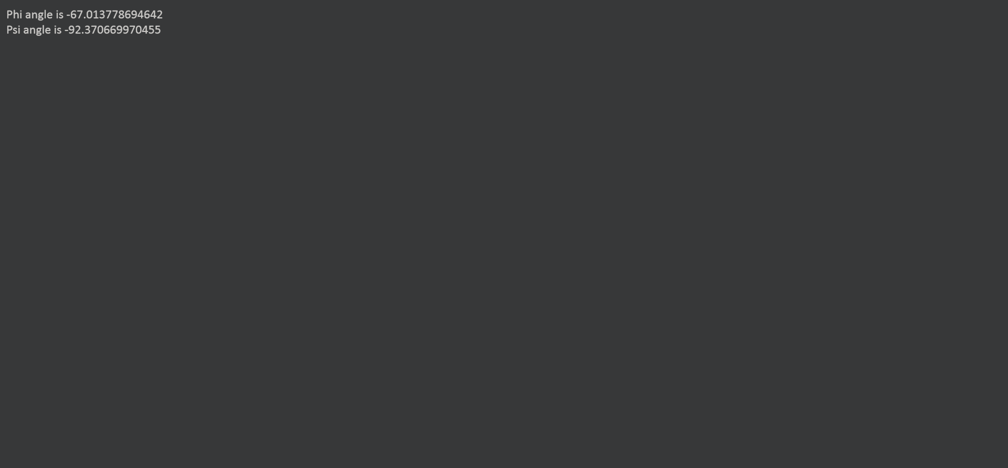

**Result:**

The given task is successfully executed.